**Export Data In Excel**

1. **Add Task Description:**

Creating a customer Data in Recycler view & Display in card view. After display it, it export in Excel file format throw Button widget. To convert Data in Excel file we use apache POI dependencies.

1. **Attach Screenshot of Output.**

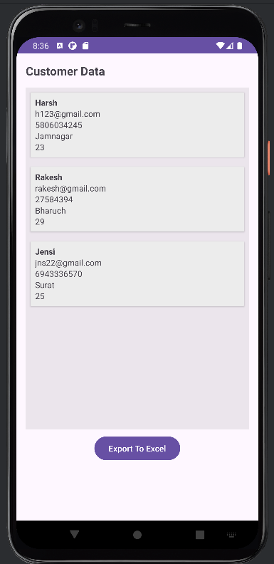 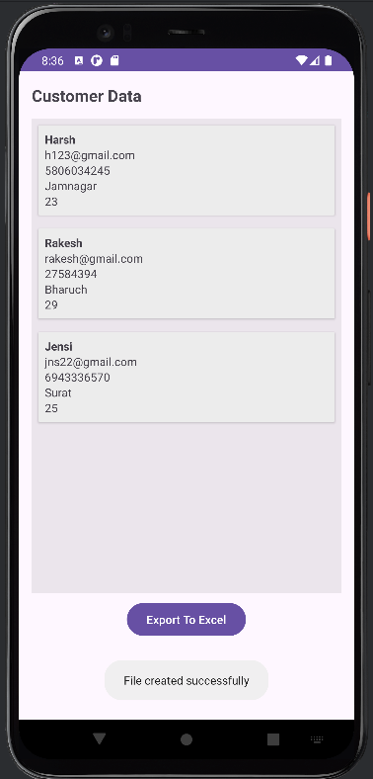

1. **Describe Widget/Algorithm Used In Task**

**Button :** widget use for Export Data in Excel file format.

**Recycler view:** used to makes it easy to efficiently display large sets of data.

**List view:** display data in vertically.

**Lib POI :** Used to Apache POI Lib to create and save Excel file.